**Assignment – Lambda Elastic Beanstalk And OpsWorks**

1. **Lambda Assignment**

**1. Create a sample Python Lambda function.**

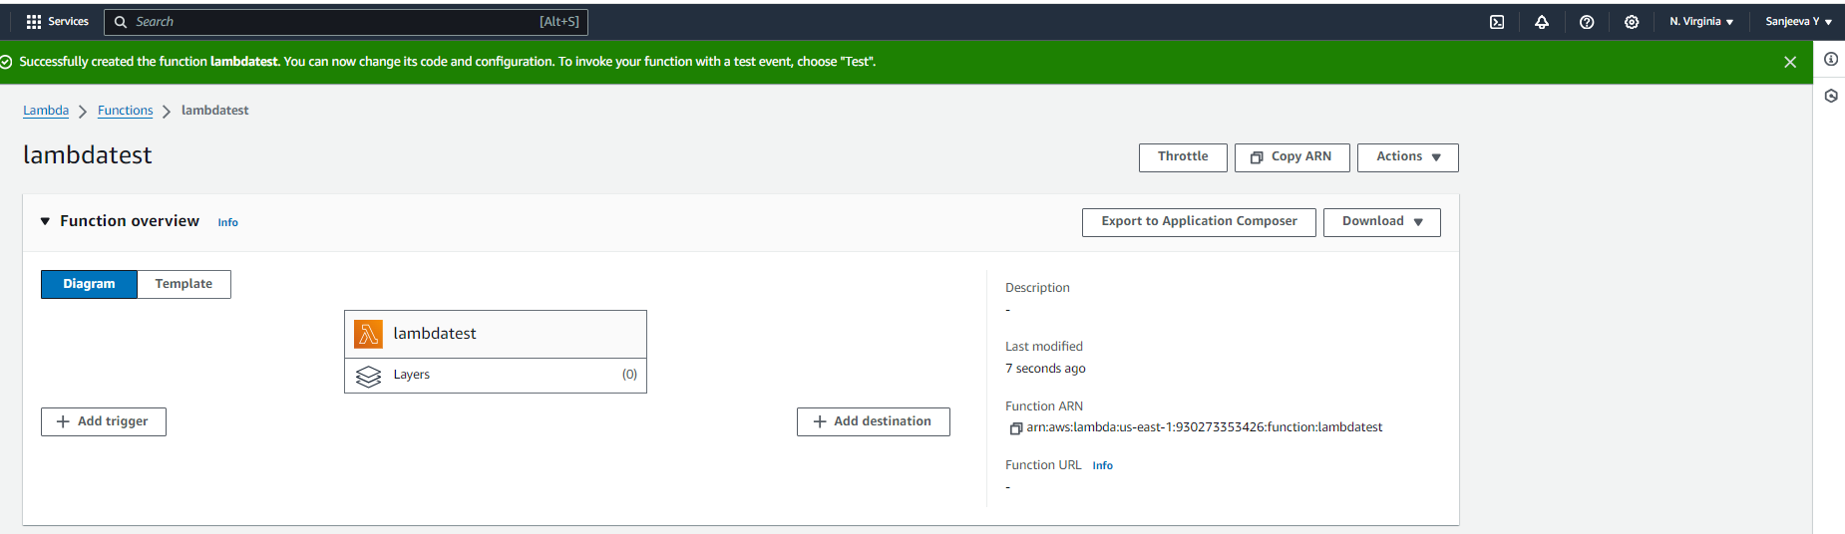

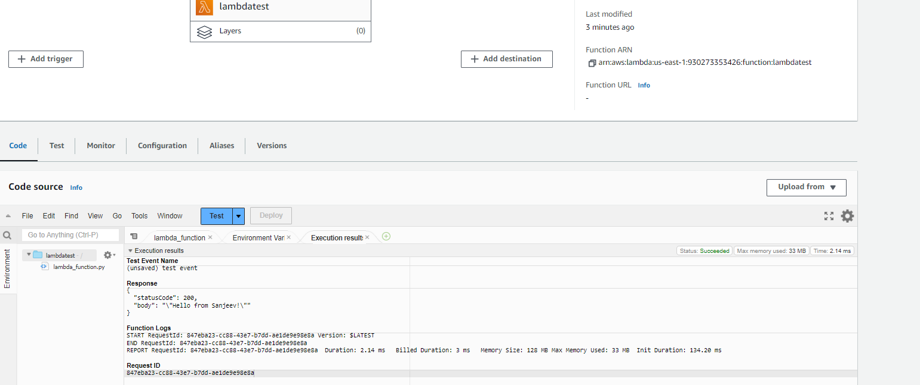

**2. Set the Lambda Trigger as SQS and send a message to test invocations**

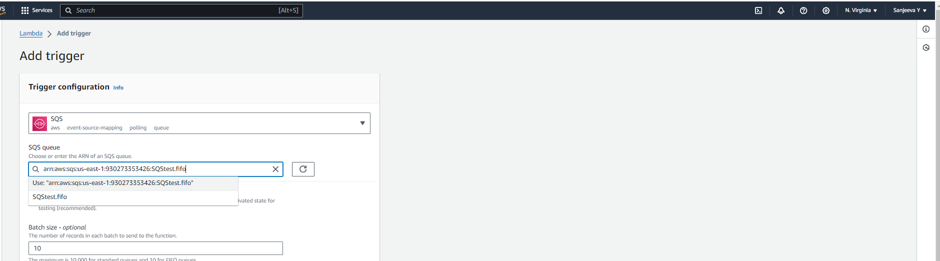

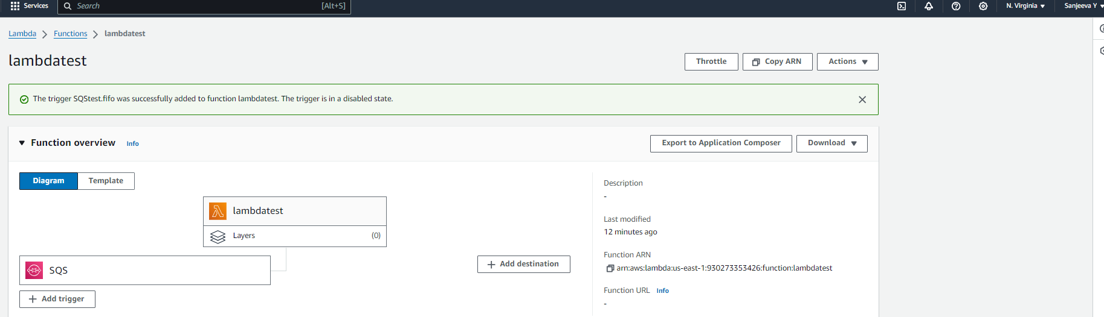

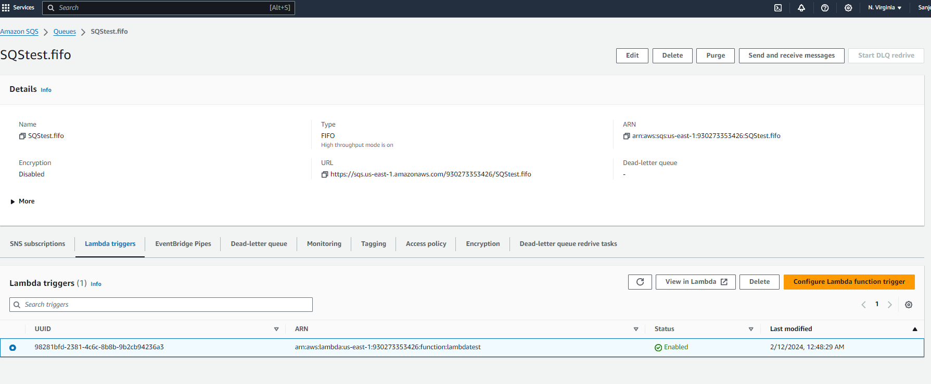

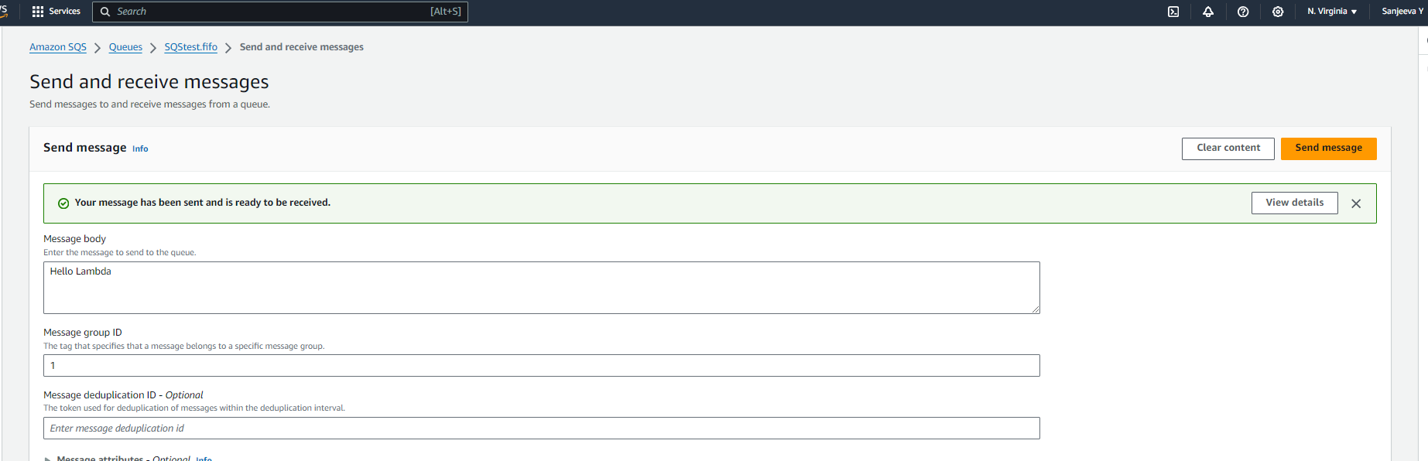

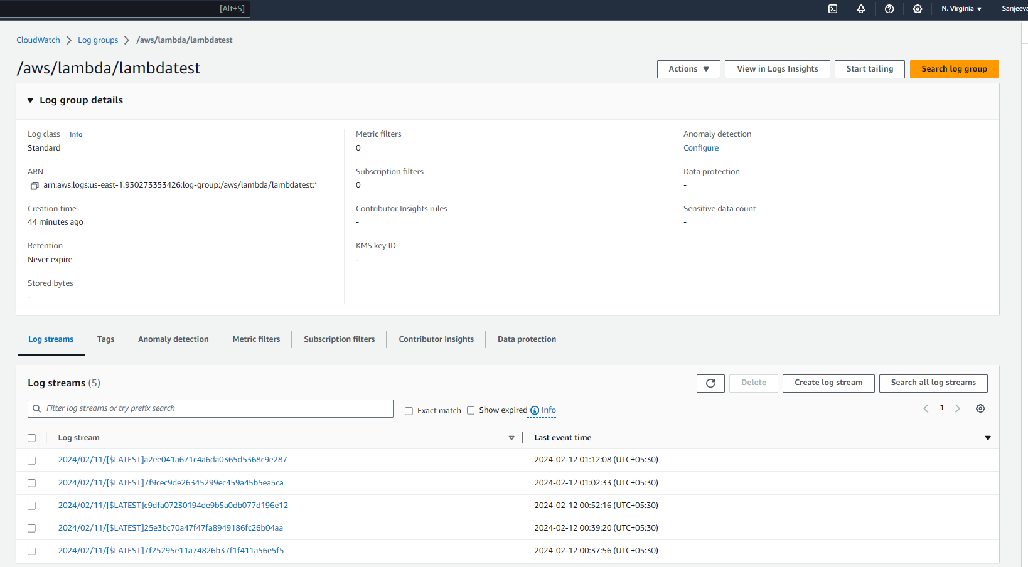

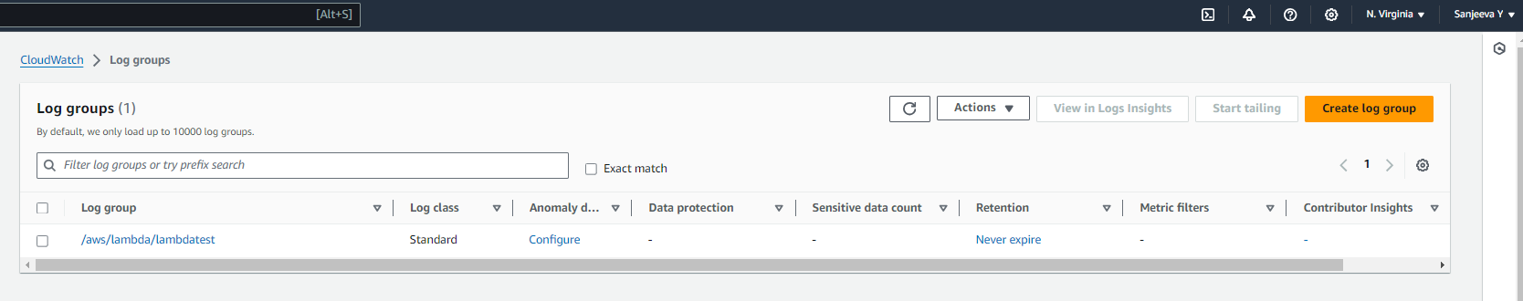

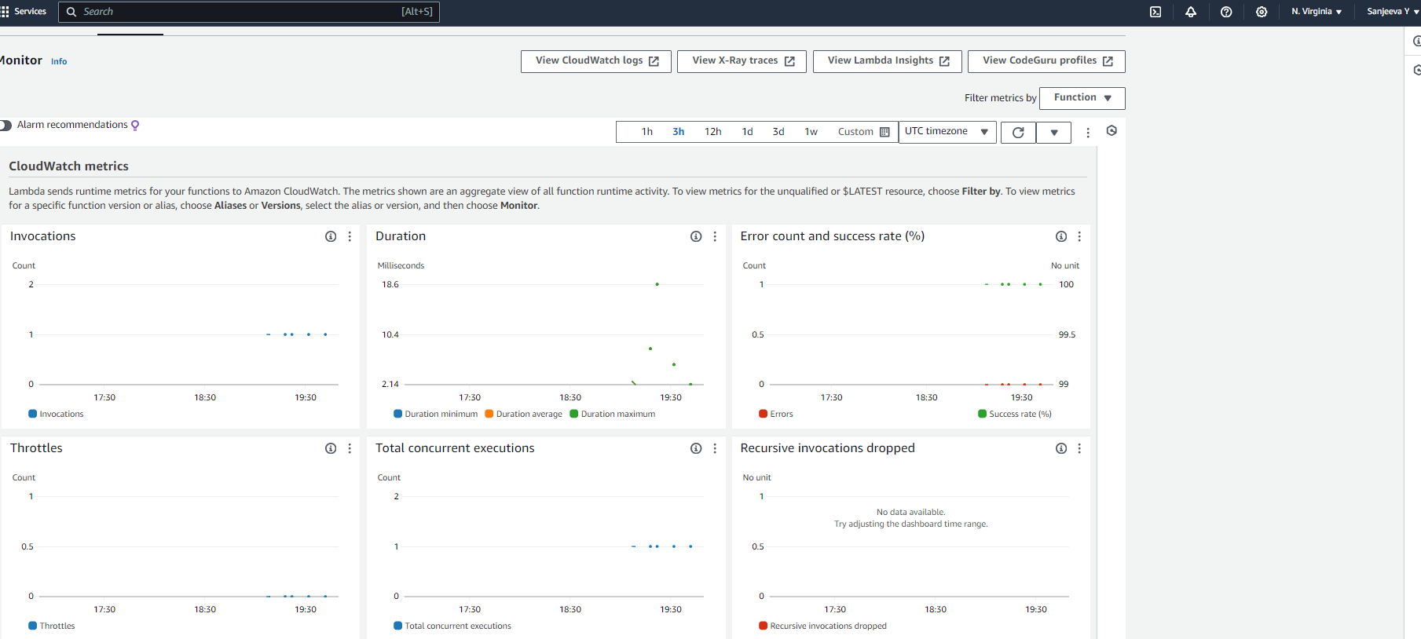

1. **Elastic Beanstalk**
2. **Create an Elastic Beanstalk environment with the runtime as PHP.**

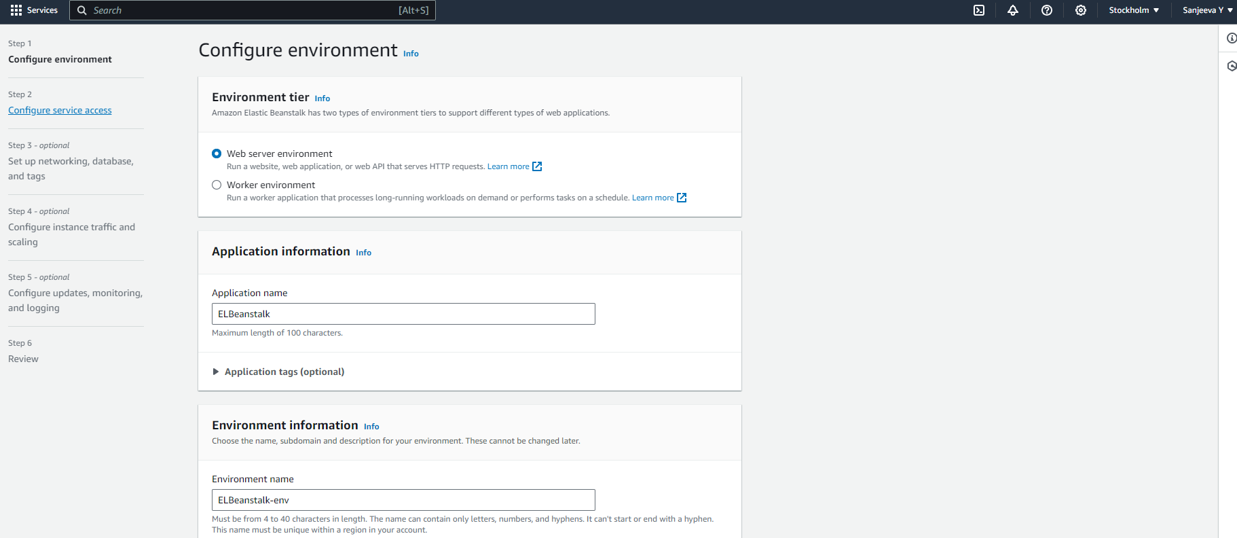

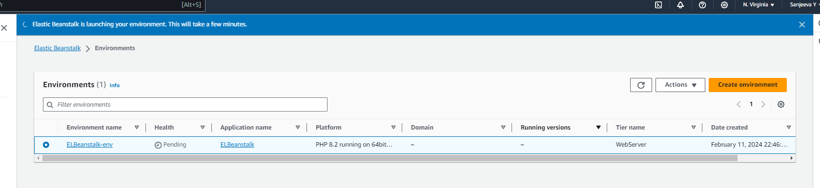

**2.Upload a simple PHP file to the environment once created.**

